  - Invitation to Quote

Strathpeffer Community Park

Fundraiser

Issued on 15/05/2019

Submission by

[Supplier to insert name here]

Contents
1. Details of services requireD 3
1.1 Introduction 3
1.2 Approach 4
1.3 Key tasks 4
1.4 Reporting 4
2. Instruction for the return of quotes 5
3. Timetable 6
4. Evaluation Criteria 6
5. Additional Information and conditions 8
5.1 Payment schedule 8
5.2 Travel and Subsistence 8
5.3 Data protection 8
5.4 Termination 8
5.5 Equality and Diversity 9
6. Quote offer letter 10
Annex I - Health & Safety and Insurance requirements 11
Annex II – Proposed park layout (Phases I and II) 12

The Scottish Land Fund is funded by the Scottish Government and made available through The National Lottery Community Fund. The Scottish Land Fund is being delivered on behalf of the Scottish Government by a partnership between the National Lottery Community Fund and Highlands and Islands Enterprise. There are no lottery funds used in the Scottish Land Fund.

Details of services requireD

Introduction
The board of the Strathpeffer Residents’ Association (SRA – hereafter referred to as ‘we’ or ‘us’) is managing the delivery of an exciting new community park through their Strathpeffer Community Park project. The project will transform 1.84 ha of boggy, unmanaged Public Open Space into a community-owned vibrant asset that will benefit local people of all ages (see proposed layout in Annex II). The land is situated in the Highland village of Strathpeffer. The project will provide multiple benefit for residents of Strathpeffer, Contin, Marybank, Scatwell and Strathconnon. It builds on a detailed feasibility study with the current priorities detailed in a Business Plan, which should be read as part of the background information to this contract.

Having successfully secured funding from the Scottish Land Fund (SLF), the project is about to enter an exciting new phase where the services of a professional and enthusiastic Project Fundraiser and Project Manager are required (funded by the SLF grant). This Statement of Requirements seeks tenders in relation to the Project Fundraiser component.

The desired outcome of this contract will be the successful funding of the first major delivery phase of the project covering:

- Drainage of the upper field
- An all-ability path network
- A toddler’s play park
- An older children’s play park

These primary elements will lay the foundation for future/additional opportunities e.g. social food-growing facilities and a bike pump-track. However, the Project Fundraiser (hereafter referred to as ‘you’) will not be expected to raise funds for these unless their inclusion helps target specific funding sources.

The total expected cost of this first phase is estimated to be c. £277,000, of which we have already raised c. £64,000 (including local fundraising, land purchase discount, SLF, EDF-Foundation Scotland). We therefore hope to raise an additional c. £213,000. We have made contact with a number of potential funders but require your expertise to manage our ongoing approach and to identify and apply to additional, currently unidentified, funders. New and innovative approaches are welcomed.

We have an ambitious timescale to raise funds and deliver this project by the 31st March 2021. This is the final date by which we must have spent the SLF grant that funds this contract (the work schedule should reflect this). An extension to this contract will be considered but will be dependent on securing additional funding.

The Project Manager contract is detailed in a separate and parallel tendering exercise (details on request or on the Public Contracts Scotland website Ref: MAY353769). You will be expected to work closely with the Project Manager to coordinate these two dependent activities. It may help your tender to read the Project Manager tender so that you understand the infrastructure outcomes and dependencies in more detail.

Approach
We are not professional fundraisers and do not therefore presume to constrain how you approach the task by setting out stringent methods. We will assess your quote based on the criteria in Section 4.

We do not expect you to contribute to our local community fundraising efforts (expected to raise c. £2,000 pa), rather, to focus on local, national and international trusts and funds.

By working closely with the Project Manager, you will develop a funding strategy. This will include considering: ease of application, timings, match funding requirements, funder’s expectations, and ongoing bureaucracy requirements. It may be necessary to bundle or split key deliverables to suit available funding sources. For example, you may decide to split the play park elements into large toddler and older child elements (c. £50,000 and £100,000 respectively), or alternatively you may wish to develop a smaller scale approach e.g. piece of equipment by piece of equipment.

The successful contractor will be given access to our existing funding applications which, along with our feasibility study and business plan, will provide valuable sources of information to support our fundraising.

Key tasks
You will perform the following key tasks:

- Attend a contract inception meeting with us (in person) within four weeks of the contract award date;
- Development and maintenance of the project Funding Strategy that will prioritise potential funding sources based on value, eligibility, compatibility, intervention rate and likelihood of success;
- Lead on the implementation of the funding strategy by developing and submitting applications. We understand that it will be important for some funders to speak directly with us and that all applications must reflect the ambitions of our community;
- Manage successful funding applications including acknowledgements, reporting and any other paperwork that we are required to complete;
- Promotion of the project and our communities ambitions to funders;
- Ensure that we are aware of all terms, conditions and reporting requirements and articulate these in a Reporting Plan.
- At the end of the contract (which may be extended if additional funding is obtained), you will provide us with recommendations on how to secure outstanding funds.
We welcome details of additional tasks that you consider necessary to achieve our funding target. These may include novel approaches not accounted for above.

Reporting
You will report to and work closely with the SRA Board. They will provide regular updates e.g. are through written or verbal reports at SRA Board meetings. Requests for information by us will be dealt with promptly, as will request from you. Excellent and demonstrable communication skills are a key requirement for this project.

Instruction for the return of quotes
The contact for this quote is:

David Genney
25 Kinellan Drive
Strathpeffer
Ross-shire, IV14 9BZ

Tel: 07762211992
Email: david.genney@strathresidents.onmicrosoft.com

You should note the timetable included at Section Three, particularly the final submission time and date. Bidders should also note the evaluation criteria included at Section Four.

Any questions or clarifications must be raised via David Genney in the first instance. All responses and additional communication will be shared with all interested parties.

The returned quote must include the Quote Offer Letter (Section Six)

The complete quote must be submitted to David Genney via email no later than 12:00 hours on the 3rd June 2019. Quotes submitted by any other means will not be considered.

Alterations and qualifications to the Invitation to this Quote Document must not be made without agreement from us. Quotes containing such alterations or qualifications may be declared void.

We shall not be liable for any expenses incurred by you in the preparation of this quote.

All prices quoted must be in Sterling and exclude Value Added Tax. Please indicate your VAT status.

Your tender will include all labour, fuel, insurance, and all other expenses of any kind, which are borne by you.

In submitting a quote, you warrant that you have complied in all respects with the requirements imposed by this Invitation to Quote Document and that it is a bona fide submission, intended to be competitive and it has not fixed or adjusted the quote by, under or in accordance with any agreement or arrangement with any other person or bidder.

In submitting a quote, you warrant that you are of sound financial standing, that you have sufficient working capital available, that you have full power and authority to enter into and carry out the Contract and that you can provide the service in accordance with the Contract.

You shall be held bound by their quote for a period of 90 days following the last date for the return of quotes.

Completed quotes will be evaluated against both Quality (Technical) and Price (Commercial) criteria. Please refer to Section Four for details of the evaluation Criteria.

Timetable

Activity | Date
Deadline for questions from bidders | 12:00 noon on 31 May 2019
Deadline for the receipt of Quotes | 12:00 noon on 3 June
Evaluation of Quotes | 5 June 2019
Contract award | 6 June 2019
Contract end | 30 March 2021

Every effort will be made to adhere to the above timescales. If this is not possible, you will be informed of any significant delays to the process as soon as possible.

Evaluation Criteria
We will secure value for money for our community and our funders. Therefore, the quote most economically advantageous to us will be successful; this will not necessarily be the lowest-priced quote.

Quotes may be disqualified for the following reasons:

- The Price is unaffordable
- Failure to submit requested information or failure to answer questions

Quotes not disqualified will be evaluated according to the following criteria, so it is important that you address these points in your submitted Quote:

Evaluation criteria |  | Weighting (%)
Price |  |  | 40
Quality |  |  | 60
 | - Evidence of having successfully raised funds for similar community projects (please provide relevant examples and references/testimonials where possible); |  | 30
 | - Demonstrable understanding of our project and timetable; |  | 10
 | - Experience of working with communities, e.g. excellent liaison/communication skills, presentation skills, and clarity of approach; |  | 10
 | - Ability to manage time flexibly, deliver tasks when required, and coordinate work with other contractors; |  | 10
Health and Safety |  |  | Mandatory
Acceptance of Conditions |  |  | Mandatory

Scoring Standards – Quality (Technical) criteria

Evaluation | Description | Score
Unacceptable | Does not meet the requirement. Does not comply and/or insufficient information provided to demonstrate that the Tenderer has the ability, understanding, experience, skills resource & quality measures required to provide the goods / services / works, with little or no evidence to support the response. | 0
Serious Reservations | Satisfies the requirement with major reservations. Considerable reservations of the Tenderer's ability, understanding, experience, skills, resources and quality measures required to provide the goods / services / works, with little or no evidence to support the response. | 1
Minor Reservations | Satisfies the requirement with minor reservations. Some minor reservations of the Tenderer's relevant ability, understanding, experience, skills, resources and quality measures required to provide the goods / services / works, with little or no evidence to support the response. | 2
Acceptable | Satisfies the requirement. Demonstration by the Tenderer of the relevant ability, understanding, experience, skills, resources and quality measures required to provide the goods / services / works, with evidence to support the response. | 3
Good | Satisfies the requirement with minor additional benefits. Above average demonstration by the Tenderer of the relevant ability, understanding, experience, skills, resources and quality measures required to provide the goods / services / works. Response identifies factors that will offer potential added value, with evidence to support the response. | 4
Excellent | Exceeds the requirement. Exceptional demonstration by the Tenderer of the relevant ability, understanding, experience, skills, resources and quality measures required to provide the goods / services / works. | 5

Additional Information and conditions

Payment schedule
The nominal value of this contract is £10,000 + VAT (where applicable²). We recognise that it would be unreasonable, given the uncertainties of funding availability, to base payment on funding success. While we require a comparable quote to deliver the tasks outlined in Section 1.2 for the duration of this contract (until March 2021), we welcome your suggestions on the payment schedule and how we determine success? While we appreciate that a lot of work will be front loaded to develop the strategy, research, apply etc.., we will expect to withhold a significant portion of the contract value till the end of the contract (final payment). These will be agreed in writing prior to the contract start date.

Any variation to the payment schedule within the project timeframe must be agreed with us, the SRA Board.

Travel and Subsistence
Travel and subsistence may be required for funders meetings. Please allow for this element, as far as possible in your quote. If your anticipated T&S budget is exhausted, additional funding will be considered by us on a case by case basis pending the availability of funds and as part of a contingency element.

Data protection
Everyone has rights with regard to how their personal information is handled. During the course of your activities you may collect, store and process personal information, and we need to be satisfied that you will recognise the need to treat such information in an appropriate and lawful manner. The information, which may be held on paper or on a computer or other media, is subject to certain legal safeguards specified in the Data Protection Act 1998 (the Act) and other regulations. The Act imposes restrictions on how you may use that information.

In order to meet our requirements, we need to be satisfied that prospective suppliers are competent to undertake the work described and have sufficient data protection policies and procedures in place.

We therefore need you to send us the following information on successful award to the framework:

- A copy of your Data Protection Policy Statement setting out your rules on data protection and indicating your knowledge of the legal conditions that must be satisfied in relation to the obtaining, handling, processing, storage, transportation and destruction of personal information.
- A statement of your current procedures for storing, processing and maintaining security in respect of personal information.

If you fail to provide suitable information, they may be regarded as ‘non-compliant’.

Termination
While we appreciate cause for termination of the contract is unlikely, we need to protect our funding and guard against undue delay to the project. With this in mind:

5.3.1 SRA may, without prejudice to any other right or remedy which it may have, terminate the Contract with immediate effect by Written notice to you, the Contractor, in the event that:

- the Contractor commits (knowingly or otherwise) a material breach, or series of breaches resulting in a material breach, of the Contract and such breach is not remediable or if capable of remedy is not remedied within 15 days of Written notice to do so; or
- if the Contractor is a limited company: it becomes unable to pay its debts or is otherwise insolvent; or a liquidator, administrator, administrative receiver, manager, or receiver is appointed to it, or over all or any part of its property and undertaking of it, or it passes a resolution or a Court makes an order that it be wound up; or
- if the Contractor is an individual: if he shall die or be adjudged incapable of managing his affairs within the meaning of Part VII of the Mental Health Act 1983 or of Part V of the Mental Health (Scotland) Act 1984; or a petition is presented for bankruptcy or the sequestration of the estate of the Contractor; or he is apparently insolvent or makes any arrangement with or for the benefit of creditors; or makes any conveyance or assignation or composition for the
- benefit of creditors; or if a trustee is appointed to manage his estate or affairs;
- if the Contractor is a partnership or firm or a number of persons acting in whatever capacity, any of the events referred to in Condition 15.1(b) or (c) occur in respect of the partnership or firm or any such person, or a petition is presented that the Contractor be wound up as an unlimited company; or
- the Contractor takes or suffers any action similar to any of the above in any jurisdiction; or
- there is a material change in the management, ownership or control of the Contractor; or
- the Contractor suspends trading; ceases to carry out business, or threatens to do either.

5.3.2 In addition to its rights of termination under 5.3.1, SRA shall be entitled to terminate the Contract by giving to the Contractor not less than 30 days’ notice to that effect.

5.3.3 Upon termination of the Contract, the Contractor shall prepare and deliver to SRA a detailed report of the work done by it on, and results of, the Services, and, without prejudice to any other of its rights, SRA may itself complete the Services or have them completed by a third party, using for that purpose (making a fair and proper allowance therefor in any payment subsequently made to the Contractor) all materials, plant and equipment on the Premises belonging to the Contractor. If termination is pursuant to 5.3.1, SRA shall not be liable to make any further payment to the Contractor until the Services have been completed in accordance with the requirements of the Contract, and shall be entitled to deduct from any amount due to the Contractor the costs thereof incurred by SRA (including SRA’s own costs). If the total cost to SRA exceeds the amount (if any) due to the Contractor, the difference shall be recoverable by SRA from the Contractor.

5.3.4 Termination under this Condition shall not prejudice or affect any right of action or remedy which shall have accrued or shall thereupon accrue to either party

Equality and Diversity
You agree to comply with the Human Rights Act 1998 and the Equality Act 2010. You will also take all reasonable steps to secure the observance of this Condition, and compliance with the Equality Act 2010 and the Human Rights Act 1998, by all agents, employees, consultants, sub-contractors and suppliers engaged by the Contractor in the execution of the Contract.

Quote offer letter
(to be completed by bidder)

Dear Sir,

I/We hereby confirm the I/we have examined the Invitation to Quote (comprising this Statement of Requirements and any other accompanying documents) and are fully satisfied as to my/our abilities and experience in all respects to satisfy all the requirements stated therein.

I/We hereby offer to execute the contract in accordance with all the terms and conditions contained within the Invitation to Quote, and any further instructions that may be provided, for the Price(s)/Rate(s) detailed in my/our submitted Quote.

Signed..............................................................................................

Print Name.......................................................................................

Company..........………………..........................................................

Date.................................................................................................

Annex I - Health & Safety and Insurance requirements
As part of any client/contractor relationship, both parties have duties under H&S legislation. Similarly, if a contractor employs sub-contractors to carry out some or all of the work contained within the specification given for the contract, all parties have health and safety responsibilities. The extent of the responsibilities of each party will depend on the individual circumstances of the project.

In order to meet our requirements, the SRA Board need to be satisfied that prospective contractors are competent to undertake the work described and have health & safety policies and procedures in place. These must address employee training and safety, and the risks and hazards associated with the work.

To this end, we require you to submit the following information:

- Evidence of Competency (e.g. qualifications, training, experience, references, CV’s etc.)

- A copy of your Health and Safety Policy Statement

- A statement showing your ‘Safe Method of Operation’ and any generic Risk Assessments for the type of work you intend carrying out (if applicable).

- A copy of both your Public Liability Insurance certificate and, where appropriate, Employer’s Liability Insurance certificates, or other evidence of insurance cover (e.g. a broker’s letter).

- A statement of your procedures for appraising the competence of any sub-contractor that you intend to use on the project.

In addition to your own statutory responsibilities under the Reporting of Injuries, Diseases and Dangerous Occurrences Regulations (RIDDOR) 2013, we will require you to report all accidents, dangerous occurrences and near-misses that occur whilst you are working for us.

The successful contractor will be required, in liaison with us, to identify hazards associated with the work, to complete the necessary COSHH (Control of Substances Hazardous to Health) and final Risk Assessments and to confirm their ‘Safe Method of Operation’ statement. This will include ensuring that any previously supplied generic risk assessments have been tailored to the specific work to be undertaken. This must be agreed with the Project Officer before the work commences.

If contractors fail to provide suitable information, in particular a Health & Safety Policy and evidence of insurance (as requested above), their tender will be regarded as ‘non-compliant’.

Annex II – Proposed park layout (Phases I and II)

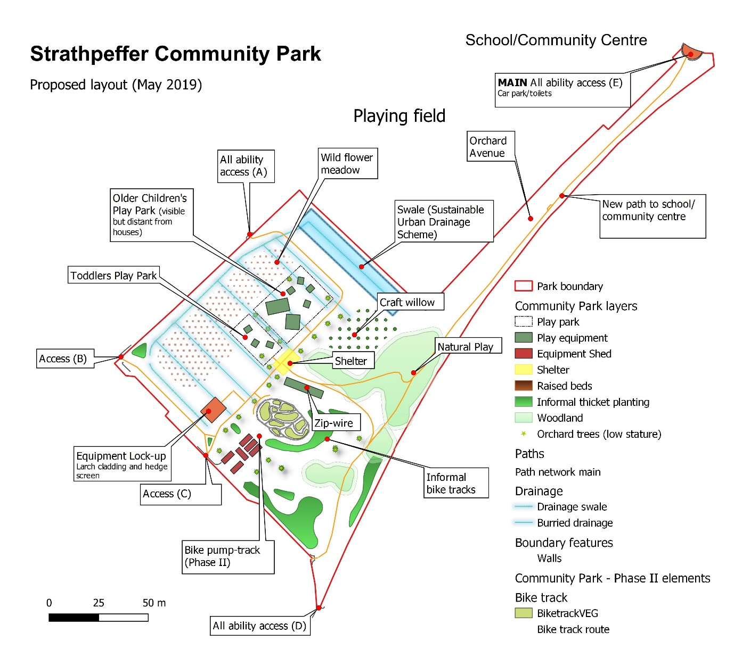

The feasibility study is available via the ‘Key Documents’ page on our project website. It contains a great deal of information on the site, constraints and opportunities. However, please note that this was based on a much more ambitious brief than will be delivered in the current business plan. The current plan is scaled back to land purchase, drainage, path network, play park.
N.B. If this contract is let as “outside the scope of VAT” (because the contracted supplier is not VAT-registered) and that supplier subsequently becomes VAT-registered during the lifetime of the contract, The SRA Board will only accept invoices with VAT added in respect of supplies made after the date of registration. The SRA Board should be provided with advance notification where VAT registration is anticipated during the period of the contract so arrangements can be made regarding the availability of additional funds.

